**Brief**

1. **Requirements specification**
   1. **Purpose statement**

|  |
| --- |
| **Non profitable organisation, increase recycling, all ages, aspirations are to lower the Earth’s pollution, formal look, to explain and show the damage we’re creating.** |

* 1. **List of requirements (functional and non-functional)**

|  |
| --- |
| **Non-functional requirements are:**   * **The website must be accessible to everyone** * **The visual focus must be on the dangers / preventions** * **The site must be ready be the 24th November**   **Functional requirements are:**   * **The website will include a contacts page, with a link to Facebook and an email form.** * **Images and videos will be included showing recycling** |

* 1. **Media Elements**

|  |
| --- |
| **1st image:**   * <https://cdn.pixabay.com/photo/2017/09/08/18/20/garbage-2729608_960_720.jpg> * **JPG** * **186 KB** * [**www.pixelbay.com**](http://www.pixelbay.com)   **2nd image:**   * <https://cdn.pixabay.com/photo/2020/05/17/06/32/factory-5180259_960_720.jpg> * [**www.pixelbay.com**](http://www.pixelbay.com) * **JPG** * **291 KB**   **Icon for the website**   * <https://cdn4.iconfinder.com/data/icons/ecology-innovicons-vol-2/256/waste-sorting-recycling-organic-512.png> * [**www.iconfinder.com**](http://www.iconfinder.com) * **PNG** * **41.6 KB**   **Recycling chart**   * <https://www.google.com/url?sa=i&url=http%3A%2F%2Fcivilengineersforum.com%2Fplastic-recycling-advantages-disadvantages%2F&psig=AOvVaw16Yul0NIZNgldKep988lJ0&ust=1604689923286000&source=images&cd=vfe&ved=0CAIQjRxqFwoTCKDLk_qN7OwCFQAAAAAdAAAAABAJ> * **PNG** * **54.8KB** * **civilengineersforum.com**   **Sea**   * <https://cdn.pixabay.com/photo/2015/03/30/12/37/jellyfish-698521_960_720.jpg> * **JPG** * **16.9KB** * [**www.pixelbay.com**](http://www.pixelbay.com)   **Forests**   * <https://cdn.pixabay.com/photo/2016/04/24/17/27/wood-1350175_960_720.jpg> * **JPG** * **125KB** * [**www.pixelbay.com**](http://www.pixelbay.com)   **Weather**   * <https://cdn.pixabay.com/photo/2015/10/15/18/21/weather-vane-989847_960_720.jpg> * **JPG** * **50.1KB** * [**www.pixelbay.com**](http://www.pixelbay.com) |

* 1. **Software and hardware requirements**

|  |
| --- |
| **Hardware: Developer**   * **Desktop** * **Laptop** * **Phone** * **Mouse** * **Keyboards** * **Connection to the internet**   **User**   * **Device with internet connection**   **Software: Developer**   * **Notepad ++** * **Image editing tools such as photoshop** * **Server** * **Browser** * **GIMP editing software**   **User**   * **Browser** |

1. **Design requirements**

**2.1. Colour Scheme**

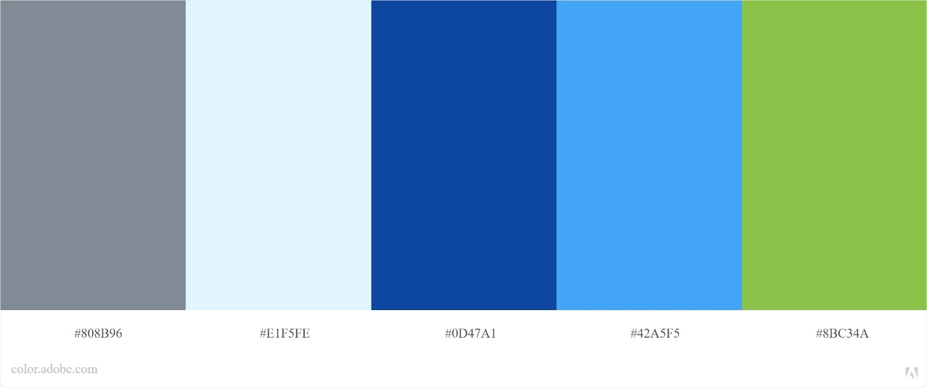

**2.2. Fonts Open Sans**

* + <link href="https://fonts.googleapis.com/css2?family=**Open+Sans:wght@600**&display=swap" rel="stylesheet">
* CSS (font-family: 'Open Sans', sans-serif;)

**2.3. Navigation Map.**

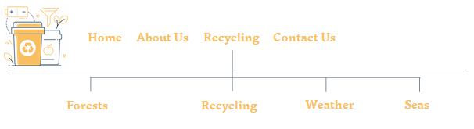

**2.4. Storyboards**

**Home:**

**Font - Open Sans**

**Body - Open Sans, 14**

**Headings – Open Sans, 20**

**Links**

**Internal – About Us,**

**Recycling, Contact Us,**

**Forests, Seas, Weather.**

**External -** [**www.facebook.com**](http://www.facebook.com)

[**www.youtube.com**](http://www.youtube.com)

**Testing**

testing plan, navigation and hyperlinks tested against three different target client systems (i.e. three different hardware/software combinations)